SATELLITE COORDINATES
AND

TECHNICAL INFORMATION GUIDE

School Safety by Management and Design

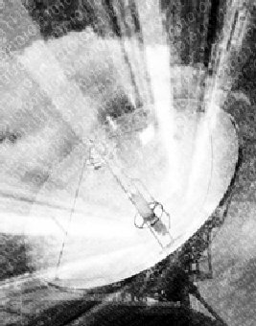

A Live National Satellite Broadcast

A Production of

The

Hamilton Fish Institute

The George Washington University

And the

Violence Prevention Project
Eastern Kentucky University

Satellite Coordinates and Technical Information Guide

Overview

It has been noticed that during previous videoconferences that some sites will try to receive a broadcast without having a technical person present who understands how to tune in the receiver. These sites often miss the videoconference and experience a high level of frustration.

Eastern Kentucky University (EKU) will only assume responsibility for program transmission. Each receiving site will be responsible for its own reception of the program. Please review page 3 for all relevant technical information.

Reception Issues

This broadcast will be aired on the C-band and Ku-band.

Video Rights

Neither EKU nor Hamilton Fish Institute possesses any specific rights to the videoconference broadcast. You are free and encouraged to videotape this event for future use. Written consent does not need to be requested.

Technical Assistance

Prior to the day of the broadcast, you are encouraged to call the EKU office at (859) 622-6163 if you need assistance.

Closed Captioning

EKU-VPP offers closed captioning for the hearing impaired for all broadcasts. Please consult your technician or the television manual to enable this option. EKU-VPP will be unable to assist with technical questions regarding the reception of closed captioning at your site.

School Safety by Management and Design

A National Satellite Videoconference

BROADCAST DATE: Thursday, October 25, 2001

TEST SIGNAL TIME: 30 minutes prior to broadcast

BROADCAST TIMES: 1:30-3:30 PM EDT
12:30-2:30 PM CDT
11:30 AM-1:30 PM MDT
10:30 AM-12:30 PM PDT

SPONSORING AGENCIES: Hamilton Fish Institute, The George Washington University

PRODUCTION AGENCY: Eastern Kentucky University-Violence Prevention Project

TAPING RIGHTS: You are encouraged to tape this program. Neither the sponsoring agencies or the production agency maintains any specific rights to this program.

C-BAND COORDINATES
SATELLITE: Galaxy 3R (95* West Longitude)
TRANSPONDER: 3
CHANNEL: 3
FREQUENCY: 3760 MHz Horizontal
AUDIO: 6.2/6.8

Ku-BAND COORDINATES
SATELLITE: Galaxy 11 (located at 91* West Longitude)
TRANSPONDER: 16
CHANNEL: 16
FREQUENCY: 12018 MHz Vertical
AUDIO: 6.2/6.8

TO TEST SIGNAL: A test signal begins 30 minutes prior to the live broadcast. Technicians should check satellite receive equipment during that time.

PROGRAM FORMAT: There will be several call-in segments during the program. Participants can interact with the studio panelists by calling 800-895-4584 when the moderator requests calls to be placed.

